SHARP SHOOTER FINISHED GOODS RETURNS STEPS

Step 1.

From Order Entry, click the Release Folder and Add a negative quantity release for the amount of finished goods being returned. When posting the bill of lading for the negative release, the system will create a positive finished goods receipts with a blank load tag number, which is used for Sharp Shooter returns.
The customer service representative processes a release just as a normal order except the quantity is negative. They can also simply click the BOL button directly from the order line item screen and bypass creating a release. Another advantage of this process is the truck driver has a formal bill of lading document for picking up the returns goods. For example, we ship 10 units at 1000 per pallet with tag numbered 1 to 10. Two units are returned by creating a negative release for 2000, which creates a bill of lading for -2 units at 1000 per unit with NO TAG Number. This in turn creates a negative invoice, thus updating the inventory with 2000 on hand without a blank tag number.

Step 2.

Load Tag creation while checking the Toggle Box called RETURNS.
Normally, when N-K-1 FGReceipt character value = LOADTAG, the load tag creation program will automatically create FG receipts for each load tag created. But this does not occur when the returns box is checked. Obviously, we do not want to create finished goods production receipts when we are just reworking the returns. Therefore, the Returns toggle will not create a receipt quantity. The logic is that the original finished goods load tags were already produced and we are now just creating new load tags for the reworked finished goods. In summary, this toggle box will prevent new finished goods receipts that would have created incorrect production totals.

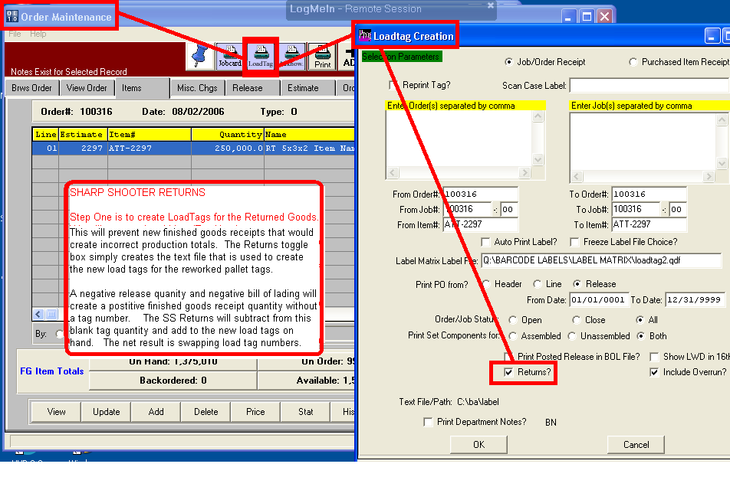
Step 3.

Sharp Shooter RETURN GOODS button is the same program as the Sharp Shooter Setup Physical count.
The F1 key will show only Load Tags that have not been received. This will show the load tags created but never received when creating the load tags with the Returns toggle box checked.. RETURNS in sharp shooter finished goods provides for receiving the new load tags by reducing the finished goods bin location with a blank tag number, exactly as the setup physical count program works. Therefore, the inventory created by the negative release will be reduced as each new load tag is scanned into the system via the Sharp Shooter Return Goods program.

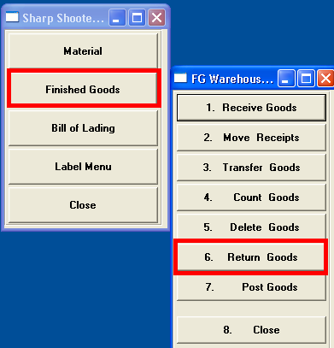

Step 4.

POST RETURNS which will also have a new toggle button called ZERO OUT RETURNS that will create a physical count for the balance not scanned during the rework process. Hence the new TOGGLE box called ZERO OUT RETURNS will create a physical count equal to 0 on hand for the blank tag number created via the negative release. This logic will be at the end of the RETURN POST logic, so that when the scanned returns are less than the bin quantity on hand for the blank tag number, a new physical count will automatically be created. This will only happen when the ZERO OUT RETURNS is checked.
For example, we ship 10 units at 1000 per pallet with tag numbered 1 to 10. Two units are returned by creating a negative release for 2000, which creates a bill of lading for -2 units at 1000 per unit with NO TAG Number. This creates a negative invoice, thus updating the inventory with 2000 on hand without a tag number. After reworking the returns we create tag number 11 with 1 unit of 1000 and tag number 12 with a pallet count of 600. The POST button of returns will reduce the blank tag number to 400 boxes. The new release will create a bill of lading for 1600 and invoice for 1600. The problem is that the remaining 400 boxes from the original negative release of 2000 are no good or trash, hence we need a physical count created for the blank tag number. By checking the ZERO OUT RETURNS toggle button, the finished goods for the blank tag number will be zero after the physical counts are posted.

